1. Swithing on the car, connecting computer to WIFI.
2. Opening e-Commerce’s IDEA project and IoT’s Pycharm project, change the setting as what we have shown in ‘before operation’ directory.
3. Run py file savelogging in IoT resource
4. Run IDEA project, it will jump to the login page automatically.

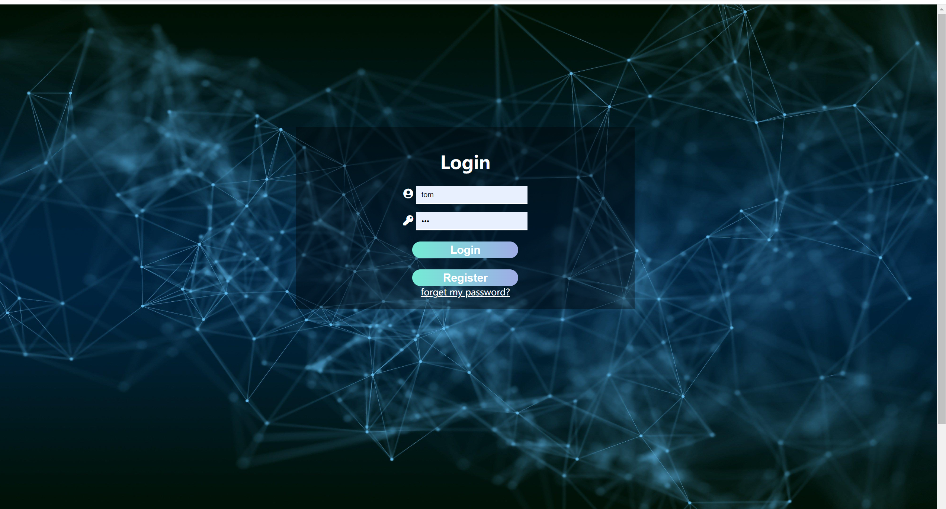

1. Login in(there will be an RCV on the bottom right if we connect to the wifi)

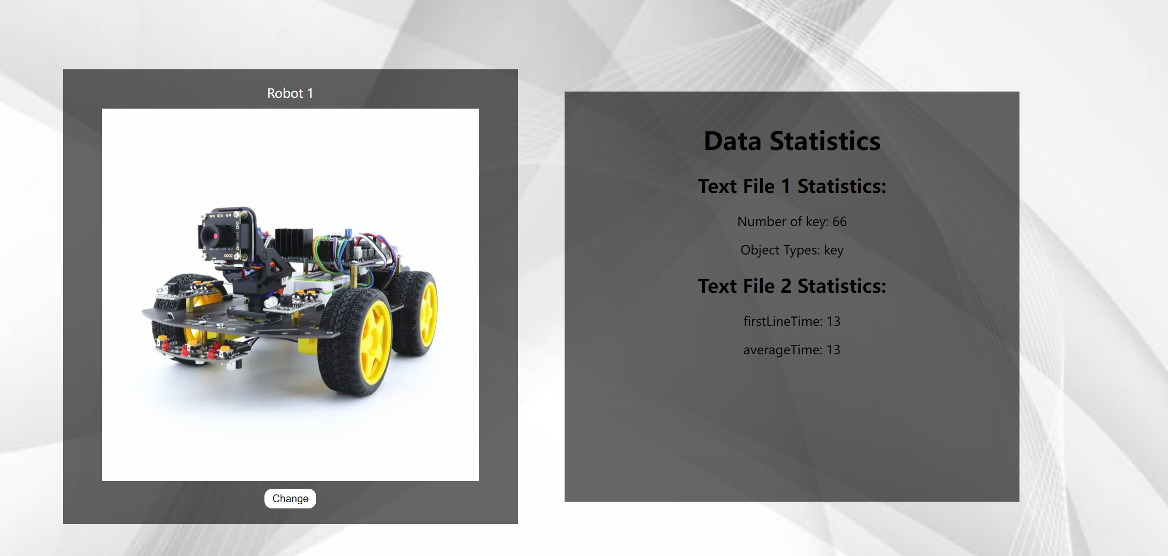

1. Put the car in the maze and start blue.py(which are used to count time)
2. Car is running and searching…
3. When our car recognize cube or key for the first time in one search, it will stop for a while
4. After the car go out from the maze, switch off the car, blue,py will stop automatically
5. The data on the web will refresh by polling.